**Address List Design Experiment Report**

Class: 网络181 Student ID 1:18401190120 Name 1: 曹鹏霄

Experiment Date:2019年9月28日

# **One、 Experimental purpose**

1.Use the basic operations to implement the speciﬁc operations for the linear table; 2.Master the application of ﬁle operations;

1. Improve the understanding of the data structure of linked storage structure, and gradually cultivate the programming ability to solve practical problems.

# **Two、Experimental environment**

A computer with visual studio 2019. This experiment has 4 class hours in all.

# **Three、Experimental content**

Design a classmate's address list, requested as follows:

Each student in the address list contains the following information:

student id、name、telephone number. If you need more ﬁelds, please add them yourself.

The program has a main menu containing the following functions:

* 1. *Add a record: Add a student record from the input.*
  2. *Delete a record: Delete a student record according to the student id from the input.*
  3. *Output all records: Display all the records in the address list.*
  4. *Search by name: Input the student name and then output the whole information of the*

*student.*

* 1. *Save records: Save all the records in the address list to a certain ﬁle.*
  2. *Clear records: Delete all the records in the address list and then*

*delete the ﬁle.*

* 1. *Quit*

# **Four、Important data structures**

**Struct introduce:**

struct Record{

string tele;//telephone string name;//name string id; //numbers

struct Record *Next;//behind point

Record() {

tele = "None"; name = "None"; id = "None"; Next = NULL;

}

};

**Function introduce:**

//head point

//const constant integer

extern Record* head_re;

const int N = 1e3;

#define Filename "data.txt"

int read_data(); //1.read data from file

int insert_record(Record*); //2.insert a record to list records void print_record(); //3.print all list records

Record *search_name(); //4.search a record from list records void save_to_file(); //5.save list records to file

int del_all(); //6.delete all records and delete file void print_main_menu(); //7.display main menu data

struct Record * new_re(); //create a struct record

# **Five、Implementation analysis**

record main menu

1.read data

2.insert

3.display

4.search

5.save

6.delete

Record list design

**using below code to display main menu**

void print_main_menu() {

cout << "|---------------Main menu |\n"\

"| 1.read data from file |\n"\ "| 2.insert a record to record list |\n"\ "| 3.print the record list |\n"\

"| 4.search record with name |\n"\

"| 5.save record list to file |\n"\ "| 6.delete all record and delete file |\n"\ "| 7.display main menu data |\n"\

"|---------------------------------------|\n" << endl;

}

**using below code to implment main menu**

while (true) {

cout << "Please enter your operation:";

//---aviod enter endless loop when cin fail---

try{

if (!(cin >> choice)) {

while(getchar() != '\n');//solve the '\n' cin.clear();

choice = 0; throw "choice";

}

switch(choice){ case 1:

read_data(); break;

case 2:

insert_record(new_re()); break;

case 3:

print_record(); break;

case 4:

search_name(); break;

case 5:

save_to_file(); break;

case 6:

del_all(); break;

}

}

catch(string &ex){

cout << ex << " not a operation, Please enter valid number:" <<

endl;

}

**1.read data**

using

fstream in_record(Filename, ios::in)

to read records from ﬁle

using is_open() to judge have a ﬁle using eof() to judge end of ﬁle

**2.insert**

int insert_record(Record *R1){

//----头插法----

R1->Next = head_re->Next;//link head next point head_re->Next = R1;//link head point

return 0;

}

**3.display**

through record list then cout they

1. **search**

through record list and compare names ,if common display the record

**5.save**

using

fstream out_record(Filename, ios::out)

**6.delete**

to save record

int del_all() {

//---delete all records and delete the file----

Record* ptr = NULL;

for (ptr = head_re->Next; ptr != NULL; ptr = ptr->Next) {

//----let head point point ptr's Next---

head_re->Next = ptr->Next;

//----then free the memory-----

free(ptr);

}

//-----delete the file----

remove(Filename); return 0;

}

* 1. *Because address lists are designed with a large amount of code, you should choose multiple ﬁles for editing instead of stacking a large number of code in one ﬁle.*
  2. *you need a menu bar as the main menu to enter the interface. The main menu can do all the operations includingAdd a record*， *Delete a record:*，*Output all records*，*Search by name*， *Save records*，*Clear records*，*Quit.*
  3. *Exit freely when inputting information*
  4. *Insertion functions can be used repeatedly in programs, so the functions of insertion*

*functions are designed to be more explicit so that calls can be made using other functions. 5*．*For insert function design, because of the need to sort, it is necessary to store the student number in the form of int or use string library to facilitate comparison. Without considering a*

*large amount of data, here we search the original data sequentially before inserting the student number every time to ﬁnd the current insertion location for insertion, that is, to point the current node to the latter node. Then point the previous node to the current node.*

# **Six、Debugging problem analysis**

**Bug 1:**

When you enter the main menu for selection, if you enter a choice that is not a digital program, you will enter a dead loop, because typing characters when reading integers in

format will cause reading failure

scanf ("%d")

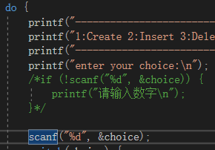

**Sovle:**

Add a judgment on scanf() reading, prompt the user when the input format is incorrect, and let the choice assign a number of non-menu options to enable it to select again

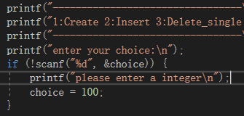

**Bug 2**

Visual studio is not allowed to use scanf () in security mode

**Sovle**

Pre-compilation by adding security mode

# define_CRT_SECURE_NO_WARNINGS

**Bug 3**

ignores the limitation of

Failure to initialize the head declaration to NULL causes errors in judging the insertion function, causing the program to crash.

struct student *head, *p;

**Sovle:**

initialize head point with NULL

**Bug 4**

Creat head point by constrcut

**Sovle:**

insead that state of Record* head_re = (Record*)malloc(sizeof(Record));

**Bug 5**

Declare head_re in the ﬁle of head.h cause error: mutideﬁne head_re

**Slove**

Using extern to declare External Variable in head.h like:

extern Record * head_re;//state external variable

Then declare head_re in main.cpp

**Bug 6**

Consfusing the parameter, instead head point pf ptr point using insert_record(). when read data

**Slove**

Change the parameter

**Bug 7**

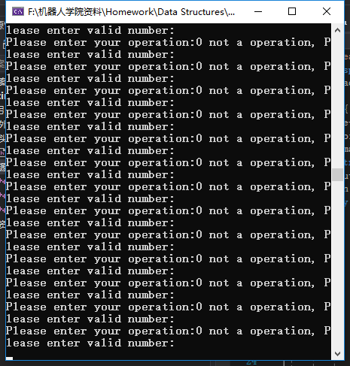No initlialize choice cause that program enter endless loop when input error

**Solve**

while(!(cin >> choice) || choice > 7 && choice <= 0) { while(getchar() != '\n');//solve the '\n' cin.clear();

choice = 0; throw "choice";

}

# **Seven、 Summary**

It is very important for a large project to have a better design concept at the beginning. It is very important to plan the project at the very beginning, and consider where to put those functions to what extent should the project be completed. If time is too late, those functions that are not particularly important should be abandoned. User interface design should be as friendly as possible.

Because of the large amount of code, many functions must be modularized, not all things in a function, we should try to build as many small functions as possible to achieve the corresponding functional blocks. In some very important details, we need to check the overall operation of the code through single-step debugging to see if the address and quantity of all variables go down as we expected.

When we encounter problems, we must actively search instead of blindly trying all kinds of useless things by ourselves. Flexible use of search tools can make us better understand many problems, because what we do on the Internet is sure that other people encounter the same problems. It is very important to actively communicate in the forum.

# **Eight、Crew Divison**

|  |  |  |
| --- | --- | --- |
|  | **Group divsion** |  |
| **Member name** | **work done** | **Comletion situation** |
| 曹鹏霄 | Address List Design | 100% |